SKI PRO 3000
Alpine Timing Equipment version 003.03B rev. A

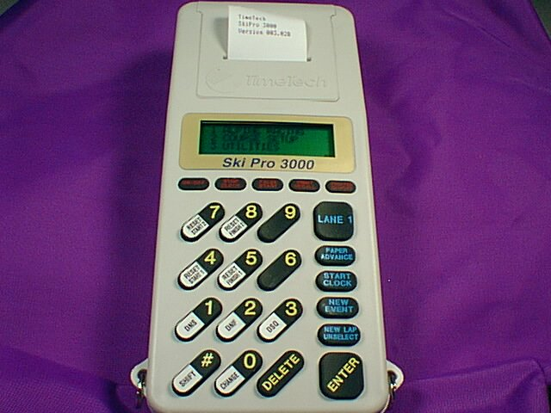

TimeTech™
Advanced Sports Timing Equipment
www.timetechusa.com
541.388.4890 (Phone)
541.388.0344 (FAX)
800.234.7950 (Toll Free)

Operations Manual

TimeTech™
2525 Twin Knolls Drive Suite B
Bend OR
USA 97701

©2000

SKI PRO 3000 1
Getting to know your Ski Pro 3000 5
Printer 5
Display 5
Keypad 5
ON/OFF 5
STOP CLOCK 5
FALSE START 5
PRINT RECALL 5
PRINTER ON/OFF 5
LANE 1 6
PAPER ADVANCE 6
START CLOCK 6
NEW EVENT 6
NEW LAP/UNSELECT 6
ENTER 6
DELETE 6
0/CHANGE 6
#/SHIFT 6
1/DNS 6
2/DNF 6
3/DSQ 7
4/RESET START 1 7
5/RESET FINISH 1 7
6 7
7/RESET START 2 7
8/RESET FINISH 2 7
9 7
Timing Channels 7
Communications Port 7
DC Power Jack 8
Batteries 8
Charging 8
Replacement 8
Strap 8
Paper 8
Loading Paper 8
Paper Care 8
Paper Jam 9
Setting Up 10
Setting Course Information 10
Changing FEET to METERS 10
Setting Start Gate Delay 11
Setting AUTO FINISH 12
Setting The Time of Day (TOD) 13
Setting TOD 13
Synchronize Timer 13
Display Clock 14
Battery Status 15
Wall Adaptor 15
Battery Volts 15
Charger Amps 15
Temperature 15
Alpine Racing 16
NASTAR (Computer Control) 16
Computer Control Mode. 16
NASTAR 16
New Race 17
Same Race 17
Enter Course Length 18
Single Course 18
Dual Course 18
Enter Pacesetter’s Handicap 18
Timing Screen 19
Single Course 19
Dual Course 19
Starting the Pacesetter 20
Entering RIN’s 20
Starting The Course Time 21
Reset Start 21
Mid-Mountain Finish 21
Finishing The Course Time 21
Reset Finish 21
Did Not Start (DNS) 21
Did Not Finish (DSF) 21
Disqualified (DSQ) 21
Running Time 22
Starting Racers 22
Change Function 23
Ending a Race 23
Reprint Current Race 23
CLUB 23
New Race 24
Same Race 24
Enter Course Length 24
Single Course 24
Dual Course 24
Timing Screen 25
Single Course 25
Dual Course 25
Entering Racer Identification Numbers (RIN’s) 25
Starting Racers 26
Starting The Course Time 26
Reset Start 26
Mid-Mountain Finish 27
Finishing The Course Time 27
Reset Finish 27
Did Not Start (DNS) 27
Did Not Finish (DSF) 27
Disqualified (DSQ) 27
Ending a Race 27
Reprint Current Race 27
FIS 28
New Race 28
Same Race 28
Enter Course Length 28
Women Run One 29
Men Run One 29
Entering RIN Numbers 29
Starting The Course Time 29
Reset Start 30
Mid-Mountain Finish 30
Finishing The Course Time 30
Reset Finish 30
Did Not Start (DNS) 30
Did Not Finish (DSF) 30
Disqualified (DSQ) 30
Stopping the Race 30
Reverse Start Order for RUN 2 30
Reprint Current Race 30
Reprint Last Event 31
Ending a Race 31
Pro Racing 31
New Race 31
Same Race 32
Entering RIN’s 32
Ending a Race 33
Contact TimeTech 34
Appendix A 35
Serial port settings 35
Serial port commands 35

Getting to know your Ski Pro 3000

Printer
The printer is of a Thermal Transfer type. You must use thermal treated paper for the printer to work correctly. This can be purchased separately from TimeTech.

Display
The display is a 4x20 character Liquid Crystal Display. It uses a technology called super twist to increase the viewing angle.

Keypad
The keypad is made from an elastomeric polymer. This gives it a long life expectancy and a nice soft feel. The Timer will emit a clicking sound once a key is pressed. The Timer will emit a click when it accepts a key press.

ON/OFF
This key is used to turn the power on and off. Press and release. When the power is off memory will still be maintained. You must hold this key down for a second for it to work. This was done to prevent accidentally turning the timer on or off.

STOP CLOCK
Use this key to end a race. This will take you back to the main menu.

FALSE START
Not used in this mode

PRINT RECALL
Pressing this key will make the printer reprint the current race data if you are still timing the race or if you have pressed the STOP CLOCK button and started a same race, it will print all race data.

PRINTER ON/OFF
This will turn printing on or off. There is a printer indicator in the lower right hand corner of the display. It is a lower case “p” when the printer is on and nothing when the printer is off. The printer can only print a line each second. The timer buffers text until the printer can ‘catch up’. Turning the printer off while it is printing empties the printer buffer. If you do not want to lose any data from a race in progress, wait until the printer has finished printing the most recent finishes before turning the printer off.

LANE 1
Not used in ski racing an will not click.

PAPER ADVANCE
If this key is pressed and released the timer will click and the paper will feed one line. If it is pressed and held the timer will beep until released and the paper will feed until released. Holding the key down will advance more than one line.

START CLOCK
Not used in ski racing.

NEW EVENT
Not used in ski racing.

NEW LAP/UNSELECT
Not used in ski racing.

ENTER
Press this button if the information entered is more than one character. For example you would press enter after entering 1000 for the distance.

DELETE
Press this key to delete the last character entered.

0/CHANGE
Press this key for the # 0. Press the SHIFT key to enable the Change function. Change is used in a NASTAR formatted race to change the AGE and SEX of a racer.

#/SHIFT
The # key is used as an escape key. Press it to return to the prior menu without making any changes. Press this key in timing mode to enable the shift functions. While in timing mode you will a lower case “s” in the lower right corner of the display indicating you are in SHIFT mode. To get out of shift mode press a shifted key (DNS, DSQ, DNF, etc.) or press the shift key again.

1/DNS
This is a shifted key. Pressing it in standard mode will give you the number 1, if you are in shift mode it will give the current racer a Did Not Start.

2/DNF
This is a shifted key. Pressing it in standard mode will give you the number 2, if you are in shift mode it will give the current racer a Did Not Finish.

3/DSQ
This is a shifted key. Pressing it in standard mode will give you the number 3, if you are in shift mode it will give the current racer a Disqualified status.

4/RESET START 1
This is a shifted key. Pressing it in standard mode will give you the number 4, if you are in shift mode it will reset the clock for the last start.

5/RESET FINISH 1
This is a shifted key. Pressing it in standard mode will give you the number 5, if you are in shift mode it will reset the clock for the last finish.

6
This will give you the number 6

7/RESET START 2
This is a shifted key. Pressing it in standard mode will give you the number 7, if you are in shift mode it will reset the clock for the last start on course 2.

8/RESET FINISH 2
This is a shifted key. Pressing it in standard mode will give you the number 4, if you are in shift mode it will reset the clock for the last finish on course 2.

9
This will give you the number 9

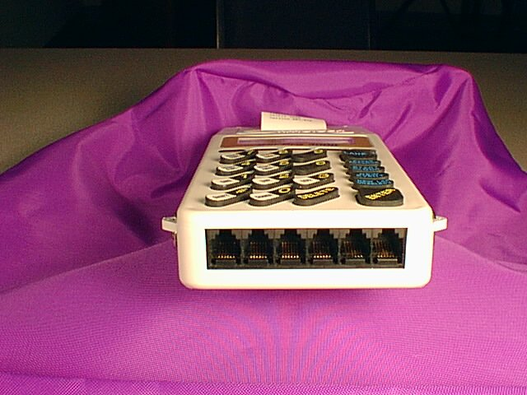
Timing Channels
There are 10 timing channels on this timer. Located across the bottom and on both sides through RJ12 jacks. The channels used for alpine are the bottom 6 starting from right with #1 and ending on the left with #6. Each port has power to run electronic finish sensors, when the timer is connected to a power supply.

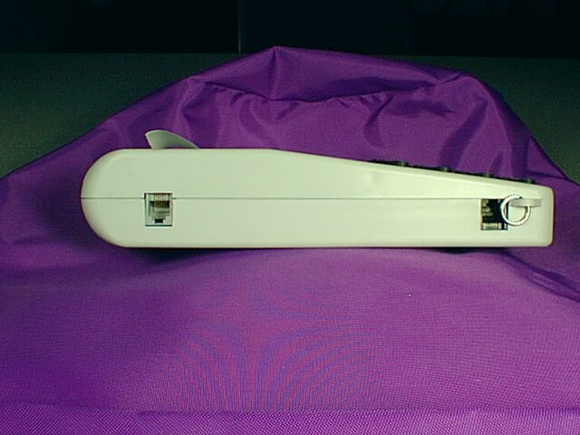
Communications Port
Located on the upper left hand side of the timer. You can connect a computer and a large display clock to this jack. There are several separate serial ports in this one jack.

DC Power Jack
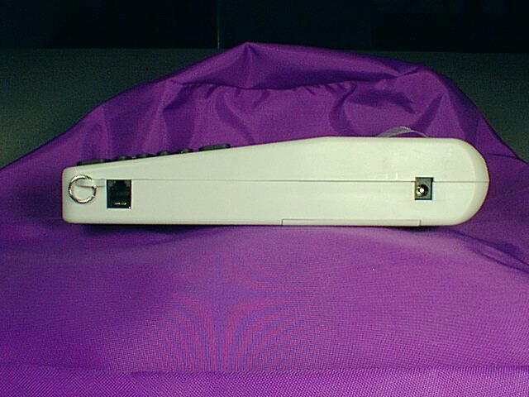
On the upper right hand side is a 2.5mm x 5.5mm jack. This connection is used in conjunction with the charger provided.

Batteries
Currently TimeTech is using AA High Capacity NiCad batteries.
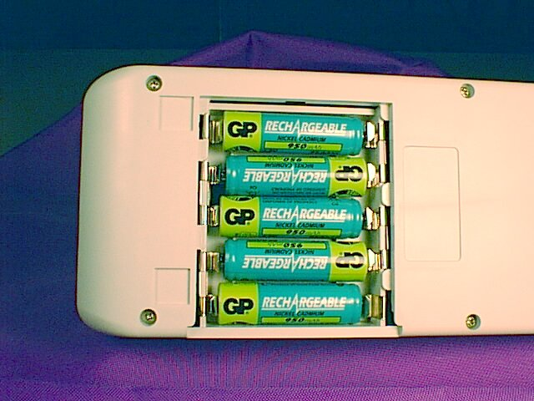

Charging
Charging will take place when the charger adaptor is connected and the batteries are low. Batteries will reach full change in approximately 2 hours. For a full charge turn off the timer and connect the DC Charger. When storing the timer leave the charger plugged in, this will keep the batteries in top condition. You can see the status of charge in utilities

Replacement
Please contact TimeTech for replacement batteries.

Strap
You can connect a strap to the timer if you prefer. It is connected to the metal rings at the bottom on both left and right sides.

Paper
Paper for the timer is specially treated for thermal printers. You must purchase thermal paper. This can be purchased from TimeTech.

Loading Paper
Paper is loaded from the top of the timer. Remove the paper door cover. Open a new roll of paper and place it into the paper-loading path. Press and hold the paper advance key until the paper is ejecting from the top of the printer mechanism. Replace the printer door making sure the paper is lined up with the slot in the printer door.

Paper Care
The paper is individually wrapped for its protection. Keep the paper in a cool dry place. With proper care the paper will last for many years.

Paper Jam
If the paper does jam it will cause the printer to stop printing. Remove the jam and the printer will continue. If you can not clear the paper jam turn off the printer with the PRINTER ON/OFF key, finish your race, and download your times to a computer. Call TimeTech’s service department for further information.

Setting Up

Setting Course Information
This section will describe settings that can be made before a race.

Entering Course Length
From main menu select “2 Course Setup” by pressing the 2 key. Now press 1 to enter the course length. All speed on course is determined by the elapsed time of the racer and the length of the course.

|| 1 ALPINE RACING ||
|| 2 COURSE SETUP ||
|| 3 UTILITIES ||
|| p||
Press 2 for course setup

|| ||
||Enter Course Length ||
|| 1200←Feet ||
|| p||
Enter the distance and press ENTER
If the distance needs to be changed press the DELETE key until the distance is cleared, then re-enter the correct distance.

Changing FEET to METERS
From the main menu select “2 Course Setup” by pressing the 2 key. By pressing the 2 key again you will toggle between feet or meters. When Feet / (Meters) is displayed all distance will be in feet and temperature will be in Fahrenheit. If Meters / (Feet) is displayed distance will be in meters and temperature will be in Celsius.

|| 1 ALPINE RACING ||
|| 2 COURSE SETUP ||
|| 3 UTILITIES ||
|| p||
Press 2 for course setup

|| 1 Course Length ||
|| 2 Feet / (Meters) ||
|| 3 Start Delay ||
|| 4 Auto Finish p||
Press 2 to toggle Feet and Meters

Setting Start Gate Delay
From the main menu select “2 Course Setup” by pressing the 2 key. Pressing the 3 key will allow you to setup the start gate delay. You will be prompted to enter a number in seconds between starts. The default value is 5 sec. If you wish to change the default setting press the DELETE key to erase the set time and enter the new time in seconds. Press the ENTER key when done. If you don’t wish to save any of the new values you have entered press the # key to escape back one menu.

|| 1 ALPINE RACING ||
|| 2 COURSE SETUP ||
|| 3 UTILITIES ||
|| p||
Press 2 for course setup

|| 1 Course Length ||
|| 2 Feet / (Meters) ||
|| 3 Start Delay ||
|| 4 Auto Finish p||
Press 3 for Start Delay

|| Start Delay Time ||
|| Enter Minimum ||
|| Time Between ||
|| Starts 5←seconds p||
Default is 5 seconds. Press the DELETE key to clear the last time entered then re-enter the time you prefer.

Setting AUTO FINISH
Auto Finish allows the timer to run unmanned. If someone on the course falls the timer will automatically finish the competitor after the pre-determined time has been reached. Default is 0 seconds. An entry of 0 seconds turns this function off.

|| 1 ALPINE RACING ||
|| 2 COURSE SETUP ||
|| 3 UTILITIES ||
|| p||
Press 2 for course setup

|| 1 Course Length ||
|| 2 Feet / (Meters) ||
|| 3 Start Delay ||
|| 4 Auto Finish p||
Press 4 for Auto Finish

|| Auto Finish Time ||
|| Enter Maximum ||
|| Possible Run Time ||
|| 0←seconds p||
Default is 0 seconds

Setting The Time of Day (TOD)

Setting TOD
From the Main menu select “3 UTILITIES” to gain access to the Time Of Day setting. Now press “1 Time of Day”. Now press “1 Set Time”. You can now set the Month/Day/Year and HH:MM:SS. You will start in the Month field. Hit the DELETE key to delete any unwanted numbers out of the field then replace them with the correct Month. Press the ENTER key after you are satisfied with the data. After pressing the ENTER key you will move to the next field. Edit that data and press enter again. Do this until you have reached the seconds field. Here you can enter the seconds and then press the ENTER key to start the time. The time will run from there. Now press the # key twice to return to the Time menu. If you wish to view the time you can now press the “2 See Time” key.

|| 1 ALPINE RACING ||
|| 2 COURSE SETUP ||
|| 3 UTILITIES ||
|| p||
Press 3 for UTILITIES

|| 1 Time of Day ||
|| 2 Display Clock ||
|| 3 Battery Status ||
|| p||
Press 1 for Time of Day

|| 1 Set Time ||
|| 2 See Time ||
|| 3 Synchronize Time ||
|| p||
Press 1 to set the time, press 2 to see current time, and press 3 to synchronize time (covered later)

Synchronize Timer
From the Main menu select “3 UTILITIES”, then “1 Time of Day”, then “3 Synchronize Time”. Now you can enter the Time of day or any other start time you wish. Enter the data into the field and press “Enter” after each field to move you to the next. The timer will wait for a Start impulse from course 1. Have other timers set up the same way to sync more than one timer. The time will begin to run when the start impulse is received. To check the Synchronization of the timers simply generate another start on course 1. This will display and print the time of the synchronized pulse. Pressing the “#” key at any time will escape to the last menu.

|| Enter ||
|| Synchronizing Time ||
|| 13:37:00.000← ||
|| Waiting for Start p||
Timer is holding for start pulse

| |
| Synchronized | Print out once start pulse received
| T02 13:37:00.000 |
| |

| Verified |
| T02 13:38:29.373 | Print out once 2nd pulse is received.
| |

|| Enter ||
|| Synchronizing Time ||
|| 13:37:00.000 ||
|| 13:38:29.373 p||
Screen will show time

Display Clock
If you have a large display clock to connect to the SkiPro3000, you can select the model from this menu.

|| 1 Select Make ||
|| 2 Display Hold Time||
|| ||
|| p||
Push 1 to select clock

||1 Electro-Numerics 5||
||2 Electro-Numerics 8||
||3 Chronomix 6 ||
||4 Chronomix 8 p||

Once you select the clock type the SkiPro will generate a signal for the clock. If you have the SkiPro 3000 connected to the Large Display clock it will start to count up. To exit the menu press the # key.

If you need to change the hold time of the display clock, use the Display Hold Time selection.

||Display Hold Time ||
||Enter Time To Hold ||
||Course Finish ||
|| 5←seconds p||
Default is 5 seconds. To change it press the DELETE key and re-enter the hold time you require.

Battery Status
In this sub menu you can get information about the battery and charge conditions. From the Main menu press “3 UTILITIES” and then “2 Battery Status”

Wall Adaptor
The top line will give you information about the wall adaptor. It will either be “No Wall Adaptor” or “Adaptor Volts: xy.z”. With the adaptor connected you will get a dynamic voltage reading.

Battery Volts
This line will give you a dynamic voltage reading of your battery.

Charger Amps
If your batteries have discharged and you attach the wall adaptor the Charger Amps line will give you a dynamic reading in mA of the charge current.

Temperature
This will give you the current temperature internally. It will change from Fahrenheit to Celsius when you make the change from Feet to Meters in the course setup.

||Adaptor Volts: 11.5 ||
||Battery Volts: 6.8 ||
||Charger Amps: 250mA||
||Temperature: 81 F ||
Battery Status Screen

Alpine Racing

NASTAR (Computer Control)
This race mode will be used when the software NASTAR provides is used. This will disable all functions of the Ski Pro 3000 and allow the computer to control all functions of the timer and race.

Computer Control Mode.
To get to this mode, remove the batteries from the timer. Locate the block of 4 DIP switches located in the empty battery compartment. Slide switch #4 to the off position as shown below. Replace the batteries and press the ON/OFF key. The Ski Pro 3000 will start normaly and then activate the Computer Control Mode. This message will be displayed on the Ski Pro 3000 screen, “Computer Control Option Selected…”

DEFAULT

Computer Control Mode

NASTAR
This race format is used in conjunction with NASTAR competitive racing. After the initial Diagnostic screen has run, you will be prompted with the Main Menu.

|| 1 ALPINE RACING ||
|| 2 COURSE SETUP ||
|| 3 UTILITIES ||
|| p||
Main Menu
Press 1 for Alpine Racing.

|| 1 NASTAR ||
|| 2 CLUB ||
|| 3 FIS ||
|| 4 PRO p||
Alpine Menu
Press 1 for NASTAR

New Race
Selecting “1 New Race” will delete any previous race data. If you are continuing a race select “2 Same Race”.
|| ||
|| 1 New Race ||
|| 2 Same Race ||
|| p||

Same Race
“2 Same Race” will keep all previous race information, and allow you to continue a current running race and time.

|| ||
|| 1 New Race ||
|| 2 Same Race ||
|| p||

Enter Course Length
Press “ENTER” if you have already set the course length in the course setup menu. If it is blank or has a different length just type in the correct length and press the “ENTER” key.
|| ||
||Enter Course Length ||
|| 1200←Feet ||
|| p||

Single Course
Selecting “1 Single Course” will set the timer for single course operation. In this mode you will be able to have 4 competitors on the course at one time.

|| ||
|| 1 Single Course ||
|| 2 Dual Course ||
|| p||

Dual Course
Selecting “2 Dual Course” will set the timer for dual course operation. In this mode you will be able to have 2 competitors on each course for a total of 4 running times.

|| ||
|| 1 Single Course ||
|| 2 Dual Course ||
|| p||

Enter Pacesetter’s Handicap
Here you will enter the Pacesetter’s handicap. Once you have entered the number press the “Enter” key to continue. If you are running a dual course you will also be prompted for the 2nd course Pacesetter handicap.

|| ||
||Enter Pacesetter's ||
||Handicap 10← ||
||Course 1 p||

|| ||
||Enter Pacesetter's ||
||Handicap 12← ||
||Course 2 p||
Once you have entered all of the pacesetter’s handicaps the printer will print a race tape header.

| NASTAR Dual |
| PsetterHcap: 10 |
| PsetterHcap: 12 |
| Feet: 1200.00 |

Timing Screen

Single Course

|| #_____←| #_____ ||
||---.---←| ---.--- ||
|| #_____ | #_____ ||
||---.--- | ---.--- p||

Dual Course

|| #_____←| #_____ ||
||---.---←| ---.---← ||
|| #_____ | #_____ ||
||---.--- | ---.--- p||

The screen is split into 4 parts. If you are in single course mode competitors will start their times in the upper left section of the screen. In dual course mode course 1 will display on the left half of the screen and course 2 will display on the right half. The blank rows with the “#” in front indicate placement of the RIN number (Racer Identification Number). The Arrow pointing at that line shows the next place where the RIN will be entered. If you press the enter key you will see that the arrow will move to the next position. In single and dual course mode the RIN arrow will move from left to right top to bottom.
The arrow on the next line down “---.---←” show the next place that will start. The “p” lower case p in the bottom right corner of the screen indicates if the printer is on or off. I the printer is on the “p” will appear. If the printer is off the “p” will not be there. If the battery voltage drops too low the printer will display an error and turn the “p” off.

Starting the Pacesetter

The Pacesetter is recognized by the SkiPro as RIN 0. RIN stands for Racer Identification Number. If you are running a dual course the pacesetter will have to be run on both for competitors to get medals awarded. If for any reason the Pacesetter cannot run the course first, all medal awards can be reprinted at any time during the race by pressing the Print Recall key. If course conditions change during the race, and a Pacesetter needs to re-run the course, end the current race by pressing the STOP CLOCK key and then start a new race.

Entering RIN’s

RIN’s (Racer Identification Number) can be entered for all competitors. If the start order is available before the race, all RIN, AGE, and SEX can be pre- downloaded to the SkiPro3000 via the serial port and a PC. There will be software to assist you in doing this. If you do not have this information, the RIN, AGE, and SEX can be entered during the race as it happens. Again RIN 0 is reserved for the Pacesetter. All other numbers up to 99999 are valid. There will be an arrow next to the RIN field that is active and waiting for the RIN input. Once this arrow is pointing where you wish simply enter the RIN by pressing the number pad followed by ENTER. Below 10 has been entered.

|| #00000 | #00010← ||
|| 14.265 | 1M2F←← ||
|| #_____ | #_____ ||
||---.--- | ---.--- p||

You can see here that the SkiPro is now asking for the SEX. Press 1 for Male and 2 for Female.

|| #00000 | #00010← ||
|| 14.265 | Age 0←← ||
|| #_____ | #_____ ||
||---.--- | ---.--- p||

Now you will be prompted to enter the age. Using the number pad enter the age and press the ENTER key.

|| #00000 | #00010 ||
|| 14.265 | ---.---← ||
|| #_____←| #_____ ||
||---.--- | ---.--- p||

That’s it. Now you are ready to enter the next RIN field. You can enter up to 4 RIN’s at one time.

Starting The Course Time
To start the time, connect a start gate to timing channel 2 on the timer using the included adaptor. All timing channels on this timer are normally open connections. Once the connection is closed the timer will start. The timer will now move the arrow to the next field that is going to start.

Reset Start
If there has been a false start for any reason press the “#/SHIFT” key to put you into SHIFT mode (denoted in the lower right corner with a “s”) and press the “4/Reset Start 1” The last start will be reset.

Mid-Mountain Finish
If you wish to have a Mid-Mountain time, connect a sensor up to timing channel 4 on the timer. You will here a beep when a racer crossed the sensor.

Finishing The Course Time
Using timing channel 6 on the timer will give you a finish. Once the finish has occurred the printer will print all information regarding that racer.

Reset Finish
If by chance there is a false finish you can clear that by pressing “#/SHIFT” key and then pressing “5/Reset Finish 1”. This will restart the last running time for a proper finish.

Did Not Start (DNS)
By pressing “#/SHIFT” and then “1/DNS” you will be prompted to enter the RIN that did not start.

Did Not Finish (DSF)
By Pressing “#/SHIFT” and then “2/DNF” you will be prompted to enter the RIN that did not finish.

Disqualified (DSQ)
By pressing “#/SHIFT” and then “3/DSQ” you will be prompted to enter the RIN that was disqualified.

Running Time

Once the start gate has been opened the timer will start a rolling time in seconds. Here is a screen shot of the pacesetter time.

|| #00000 | #_____← ||
|| 14.265 | ---.---← ||
|| #_____ | #_____ ||
||---.--- | ---.--- p||

Once the pacesetter has crossed the finish the printer will print the following:

| #00000 00:14.265 | RIN # elapsed time
| PAR1 00:12.968 | Calculated par time
| 57.36 mi/hr | Speed of Pacesetter
| |

Starting Racers
After the pacesetters have run the competitors can start. Follow the same process as the pacesetter start; open the start wand to start the next competitor. The display will show an arrow next to the time that will start.

|| #00106 | #00010 ||
||---.--- | ---.---← ||
|| #00011←| #00107 ||
||---.--- | ---.--- p||
Arrow showing next start

|| #00106 | #00010 ||
||---.--- | 5.000 ||
|| #00011←| #00107 ||
||---.---←| ---.--- p||
Running Time

| #00010 00:18.923 | RIN and Elapsed Time
| 46 M55 C1 | Handicap Sex/Age Course#
| SILVER 1.81 | Medal awarded Time needed to achieve next medal
| 43.24 mi/hr | Total average speed of racer
| |
Competitor print out

Change Function

If the age and sex were entered incorrectly for a racer press ENTER until the arrow points to the incorrect RIN and then press the SHIFT key followed by the CHANGE key. You will be prompted to re-enter the age and sex of that RIN. If the racer has a finish time you will not be able to change the age and sex.

Ending a Race
To stop a race press the STOP CLOCK key. This will take you back out to the main menu. If this key is pressed in error simply start the same race type and select same race from the menu options.

Reprint Current Race
To reprint the current race simply press the “PRINT RECALL” key before you Stop the current race.

CLUB

This race format is used in most general competitive racing not requiring any type of calculation. After the initial Diagnostic screen has run, you will be prompted with the Main Menu.

|| 1 ALPINE RACING ||
|| 2 COURSE SETUP ||
|| 3 UTILITIES ||
|| p||
Main Menu
Press 1 for Alpine Racing.

|| 1 NASTAR ||
|| 2 CLUB ||
|| 3 FIS ||
|| 4 PRO p||
Alpine Menu
Press 2 for CLUB

New Race
Selecting “1 New Race” will delete any previous race data. If you are continuing a race select “2 Same Race”.
|| ||
|| 1 New Race ||
|| 2 Same Race ||
|| p||

Same Race
“2 Same Race” will keep all previous race information, and allow you to continue a current running race and time.

|| ||
|| 1 New Race ||
|| 2 Same Race ||
|| p||

Enter Course Length
Press “ENTER” if you have already set the course length in the course setup menu. If it is blank or has a different length just type in the correct length and press the “ENTER” key.
|| ||
||Enter Course Length ||
|| 1200←Feet ||
|| p||

Single Course
Selecting “1 Single Course” will set the timer for single course operation. In this mode you will be able to have 4 competitors on the course at one time.

|| ||
|| 1 Single Course ||
|| 2 Dual Course ||
|| p||

Dual Course
Selecting “2 Dual Course” will set the timer for dual course operation. In this mode you will be able to have 2 competitors on each course for a total of 4 running times.

|| ||
|| 1 Single Course ||
|| 2 Dual Course ||
|| p||

Timing Screen

Single Course
|| #_____←| #_____ ||
||---.---←| ---.--- ||
|| #_____ | #_____ ||
||---.--- | ---.--- p||

Dual Course

|| #_____←| #_____ ||
||---.---←| ---.---← ||
|| #_____ | #_____ ||
||---.--- | ---.--- p||

The screen is split into 4 parts. If you are in single course mode competitors will start their times in the upper left section of the screen. In dual course mode course 1 will display on the left half of the screen and course 2 will display on the right half. The blank rows with the “#” in front indicate placement of the RIN number (Racer Identification Number). The Arrow pointing at that line shows the next place where the RIN will be entered. If you press the enter key you will see that the arrow will move to the next position. In single and dual course mode the RIN arrow will move from left to right top to bottom.
The arrow on the next line down “---.---←” show the next place that will start. The “p” lower case p in the bottom right corner of the screen indicates if the printer is on or off. I the printer is on the “p” will appear. If the printer is off the “p” will not be there. If the battery voltage drops too low the printer will display an error and turn the “p” off.

Entering Racer Identification Numbers (RIN’s)

RIN’s (Racer Identification Number) can be entered for all competitors. If the start order is available before the race, all RIN data can be pre downloaded to the SkiPro3000 via the serial port and a PC. There will be software to assist you in doing this. If you do not have this information, it can be entered during the race as it happens. All other numbers from 0 to 99999 are valid. There will be an arrow next to the RIN field that is active and waiting for the RIN input. Once this arrow is pointing where you wish, enter the RIN by pressing the number pad followed by ENTER. Below 10 has been entered.

|| #00000 | #00010← ||
|| 14.265 | ---.---← ||
|| #_____ | #_____ ||
||---.--- | ---.--- p||

That’s it. Now you are ready to enter the next RIN field. You can enter up to 4 RIN’s at one time.

Starting Racers
Open the start wand to start the competitor. The display will show an arrow next to the time that will start.

|| #00106 | #00010 ||
||---.--- | ---.---← ||
|| #00011←| #00107 ||
||---.--- | ---.--- p||
Arrow showing next start

|| #00106 | #00010 ||
||---.--- | 5.000 ||
|| #00011←| #00107 ||
||---.---←| ---.--- p||
Running Time

Starting The Course Time
To start the time, connect a start gate to timing channel 2 on the timer using the included adaptor. All timing channels on this timer are normally open connections. Once the connection is closed the timer will start. The timer will now move the arrow to the next field that is going to start.

Reset Start
If there has been a false start for any reason press the “#/SHIFT” key to put you into SHIFT mode (denoted in the lower right corner with a “s”) and press the “4/Reset Start 1” The last start will be reset.

Mid-Mountain Finish
If you wish to have a Mid-Mountain time simply connect a sensor up to timing channel 4 on the timer. You will here a beep when a racer crossed the sensor.

Finishing The Course Time
Using timing channel 6 on the timer will give you a finish. Once the finish has occurred the printer will print all information regarding that racer.

Reset Finish
If by chance there is a false finish you can clear that by pressing “#/SHIFT” key and then pressing “5/Reset Finish 1”. This will restart the last running time for a proper finish.

Did Not Start (DNS)
By pressing “#/SHIFT” and then “1/DNS” you will be prompted to enter the RIN that did not start.

Did Not Finish (DSF)
By Pressing “#/SHIFT” and then “2/DNF” you will be prompted to enter the RIN that did not finish.

Disqualified (DSQ)
By pressing “#/SHIFT” and then “3/DSQ” you will be prompted to enter the RIN that was disqualified.

Ending a Race
To stop a race press the STOP CLOCK key. This will take you back out to the main menu. If this key is pressed in error simply start the same race type and select same race from the menu options.

Reprint Current Race
To reprint the current race simply press the “PRINT RECALL” key before you Stop the current race.

FIS
FIS is a worldwide governing body. Using a series of calculations and specifications for each race provides a sanctioned racing environment.

|| 1 ALPINE RACING ||
|| 2 COURSE SETUP ||
|| 3 UTILITIES ||
|| p||
Main Menu
Press 1 for Alpine Racing.

|| 1 NASTAR ||
|| 2 CLUB ||
|| 3 FIS ||
|| 4 PRO p||
Alpine Menu
Press 4 for PRO racing

New Race
Selecting “1 New Race” will delete any previous race data. If you are continuing a race select “2 Same Race”.
|| ||
|| 1 New Race ||
|| 2 Same Race ||
|| p||

Same Race
“2 Same Race” will keep all previous race information, and allow you to continue a current running race and time.

|| ||
|| 1 New Race ||
|| 2 Same Race ||
|| p||

NOTE: These menus will only appear if there is a race in memory

Enter Course Length
Entering the Course Length will allow the timer to calculate the total speed of the racer. If you have already set the Course Length in the Course Setup menu it will be displayed here, simply press, “ENTER” to continue.

|| ||
||Enter Course Length ||
|| 1200←Feet ||
|| p||
To change press the delete key and re-enter the correct distance

Women Run One
Press “1 Women Run One” If you are going to run a Women’s race. After you have finished Run one of the Women’s race you will be presented with an option to run Women Run Two.
|| 1 Women Run One ||
|| 2 Men Run One ||
|| ||
|| p||
press 1 for Women, and 2 for Men’s run one.
| FIS |
| Run 1 |
| WOMEN | Race header printout
| |

Men Run One
Same as above but for the Men

Entering RIN Numbers
A “RIN” number is a Racer Identification Number, usually worn on the competitor during the race. When you are in the Timing mode the RIN field is denoted with a “#”. Enter the RIN in and press, “ENTER” to go to the next RIN field. You will notice that an arrow will travel around from field to field showing which field is active. If a RIN is not entered by the time a racer starts the Timer will automatically generate one starting at 99999 and counting down.

Starting The Course Time
To start the time, connect a start gate to timing channel 2 on the timer using the included adaptor. All timing channels on this timer are normally open connections. Once the connection is closed the timer will start. The timer will now move the arrow to the next field that is going to start.

Reset Start
If there has been a false start for any reason, press the “#/SHIFT” key to put you into SHIFT mode (denoted in the lower right corner with a “s”) and press the “4/Reset Start 1” The last start will be reset.

Mid-Mountain Finish
If you wish to have a Mid Mountain time, connect a sensor up to timing channel 4 on the timer. You will hear a beep when a racer crossed the sensor.

Finishing The Course Time
Using timing channel 6 on the timer will give you a finish. Once the finish has occurred the printer will print all information regarding that racer.

Reset Finish
If by chance there is a false finish you can clear that by pressing “#/SHIFT” key and then pressing “5/Reset Finish 1”. This will restart the last running time for a proper finish.

Did Not Start (DNS)
By pressing “#/SHIFT” and then “1/DNS” you will be prompted to enter the RIN that did not start.

Did Not Finish (DSF)
By Pressing “#/SHIFT” and then “2/DNF” you will be prompted to enter the RIN that did not finish.

Disqualified (DSQ)
By pressing “#/SHIFT” and then “3/DSQ” you will be prompted to enter the RIN that was disqualified.

Stopping the Race
To stop a race, press the “STOP CLOCK” button. This will take you back to the main menu and here you will be able to set up for your next race.

Reverse Start Order for RUN 2
After you have raced all competitors in run 1 you can move on to run 2. The timer will prompt you for the option of RUN 2 only after there has been a run 1.

Reprint Current Race
To reprint the current race press the “PRINT RECALL” key before you Stop the current race.

Reprint Last Event
To reprint the entire race results for Men and Women, press the “STOP CLOCK” to end the current race. From the Main Menu select “1 Alpine Racing” and then “3 FIS”. From here if you press the “PRINT RECALL” button the results will be printed.

Ending a Race
To stop a race, press the STOP CLOCK key. This will take you back out to the main menu. If this key is pressed in error, start the same race type and select same race from the menu options.

Pro Racing

Pro Racing format is used when an elapsed time is not needed. In essence it is a differential timer in this mode. Only the difference between finish times are calculated giving you a WINNER for the first to cross the finish and the elapsed time before the second competitor finishes.

|| 1 ALPINE RACING ||
|| 2 COURSE SETUP ||
|| 3 UTILITIES ||
|| p||
Main Menu
Press 1 for Alpine Racing.

|| 1 NASTAR ||
|| 2 CLUB ||
|| 3 FIS ||
|| 4 PRO p||
Alpine Menu
Press 4 for PRO racing

New Race
Selecting “1 New Race” will delete any previous race data. If you are continuing a race select “2 Same Race”.
|| ||
|| 1 New Race ||
|| 2 Same Race ||
|| p||

Same Race
“2 Same Race” will keep all previous race information, and allow you to continue a current running race and time.

|| ||
|| 1 New Race ||
|| 2 Same Race ||
|| p||

| Pro Race |
| | PRINT OUT
| |

|| #_____←| #_____ ||
||---.----| ---.---- ||
|| #_____ | #_____ ||
||---.----| ---.---- p||
Pro Race timing screen

|| #99999 | #99998 ||
|| Winner | 3.8598 ||
|| #_____←| #_____ ||
||---.----| ---.---- p||
Winner and time difference displayed.
| #99999 #99998 |
| Winner 3.8598 | PRINT OUT
| |

Entering RIN’s

RIN’s (Racer Identification Number) can be entered for all competitors. If the start order is available before the race, all RIN data can be pre-downloaded to the SkiPro3000 via the serial port and a PC. There will be software to assist you in doing this. If you do not have this information, it can be entered during the race as it happens. All other numbers from 0 to 99999 are valid. There will be an arrow next to the RIN field that is active and waiting for the RIN input. Once this arrow is pointing where you wish, enter the RIN by pressing the number pad followed by ENTER. If no RIN is entered one will be auto generated starting at 99999 and counting down.

Ending a Race
To stop a race, press the STOP CLOCK key. This will take you back out to the main menu. If this key is pressed in error simply start the same race type and select same race from the menu options.

Contact TimeTech

To contact TimeTech:

Sales (800) 234-7950
Service (541) 388-4890
FAX (541) 388-0344

WEB: www.timetechusa.com

E-Mail service@timetechusa.com
info@timetechusa.com
sales@timetechusa.com

Address:
TimeTech
2525 Twin Knolls Drive
Suite B.
Bend, OR 97701

TimeTech
PO BOX 9190
Bend, OR 97708

Please call before you send any items in for Repair or Credit.

Appendix A

Serial port settings
Settings for Serial Port on Ski Pro3000

9600 BAUD
8 Data bits
N No Parity
1 Stop Bit

Serial port commands
Once a link has been established between the HOST computer and the SkiPro3000, you will be able to send commands and receive responses from the SkiPro3000.

When the SkiPro3000 is ready to receive a command you will be prompted with a >. All commands must me in caps

Command | Description
P? | Returns Printer status True or False, True=on, False=off
PON | Turns Printer ON
POFF | Turns Printer OFF
V? | Returns Virtual Printer Status True=ON, False=OFF
VON | Turns Virtual Printing ON, With Virtual printing on all charictors and formating that are sent to the printer are also sent to the serial port. For example when VP is on when you turn on the printer the following will be sent to the serial port  | TimeTech |  | SkiPro 3000 |  | Version 003.02B |  | |  | |
VOFF | Turns Virtual Printing OFF
MSG | Will display a message on the SkiPro3000 display for 5 seconds. Format MSG HELLO would display HELLO on the display for 5 seconds.  >MSG HELLO
TIME? | Enter TIME? and the SkiPro3000 will send the current time:  >TIME? Wed Nov 8 11:08:32 2000  11/08/2000 11:08:32
TIME | Allows you to enter the time:  >TIME 00 08 12 08 11 2000  timer returns:  Wed Nov 8 12:08:00 2000  Format ss mm hh dd mm year
BEEP | SkiPro3000 will emit a shot beep
LIST | Will return all racer record data  >LIST  0: 0,0, 0,3,0,1,0,282970737  1: 0,0, 0,3,0,3,0,129317  2: 0,0, 0,3,0,1,1,282998474  3: 0,0, 0,3,0,3,1,134926  4: 10,1,55,3,0,1,0,283227907  5: 10,1,55,3,0,3,0,122931  6: 5,1,55,3,0,1,1,283246694  7: 5,1,55,3,0,3,1,125230
  Field | Value | Description
  1 | 0-99999 | Up to 5 digit RIN
  2 | 0, 1 | 0=Female, 1=Male
  3 | 0-127 | Racer age
  4 | 0, 1, 2, 3 | Racer Status, 0=DNS, 1=DSQ, 2=DNF, 3=DOK
  5 | 0, 1, 2, 3 | Race Type, 0=NASTAR, 1= CLUB, 2=FIS, 3=PRO
  6 | 0, 1, 2, 3 | Record Type, 0=RID, 1=Start TOD, 2=Mid MET, 3=Finish FET
  7 | 0, 1 | 0=A or Left, 1=B or Right
  8 | TIME | 0.0001 Seconds
# | Send racer records from HOST computer to the SkiPro3000  # 352,0,33  This statement will load RIN#352 Female age 33 into the race table.  DO NOT SKIP FIELDS.

